SUPERVISOR MODULE USER MANUAL

**COLLEGE OF BUSINESS EDUCATION**



**FYPMS STUDENT MODULE USER MANUAL**

**2023**

Contents

**1.** **INTRODUCTION** 4

**2.** **PURPOSE** 4

**3.** **PREREQUISITE** 4

**4.** **NEW FYPMS USERS** 4

**5.** **LOGIN TO FYPMS** 4

**6.** **USING SUPERVISOR MODULE** 5

**6.1** **Management Feature** 6

**6.1.1** **Assess Groups** 7

**7.** **Announcement** 7

**8.** **Log Out** 8

LIST OF FIGURES

Figure 1 FYPMS Login Page 5

Figure 2 Supervisor Features 6

Figure 3 Management features 6

Figure 4 assess group 7

Figure 5 Announcement feature 7

1. **INTRODUCTION**

The initiative aims at creating a platform on which supervisor can, for example

View assigned groups, view group members and assess groups according to their project presentations.

The Final Year Project Management System (FYPMS) is a web‐based application developed for management of students’ academic in case of their final year project under department of ICT at CBE (Dar Es Salaam Campus). FYPMS provides all necessary functionalities for tracking and managing both Student and Supervisor at once and all their management activities. It is a one stop centre for students to perform their Final Year Project Related activities and retrieve data related to their activities.

1. **PURPOSE**

The purpose of this user manual is to provide detailed instructions and procedures for students to navigate and understand how the student module works based on predefined student roles in FYPMS. This will improve help them to use the system efficiently.

1. **PREREQUISITE**

For a student to be able to use the student module in FYPMS, the following requirements must be fulfilled:

3.1. Must be a registered student

3.2. Must have valid username and password

3.3. Must be connected to the internet

1. **NEW FYPMS USERS**

New supervisor should use their email as “Username.” And Default password will be sent to their email After being registered at the coordinator’s office, a supervisor will be able to use the emailed password. He/she will use the email address as his/her username and password to login to the system. After a success login a system will prompt you to change your password. The new password must contain not less than eight (8) characters in which capital letters, small letters, special symbol and numbers must be used. 5.

1. **LOGIN TO FYPMS**

To access and login to FYPMS, visit CBE website (<http://domain.example/login>) and click FYPMS link which will take you to the FYPMS login page. Enter correct and valid username and password to use the FYPMS. You can also access FYPMS by directly typing the FYPMS <http://domain.example/login> as shown in Figure 1. Provided that your device is connected to the internet, the browser will direct you to the FYPMS login page

Figure 1 FYPMS Login Page

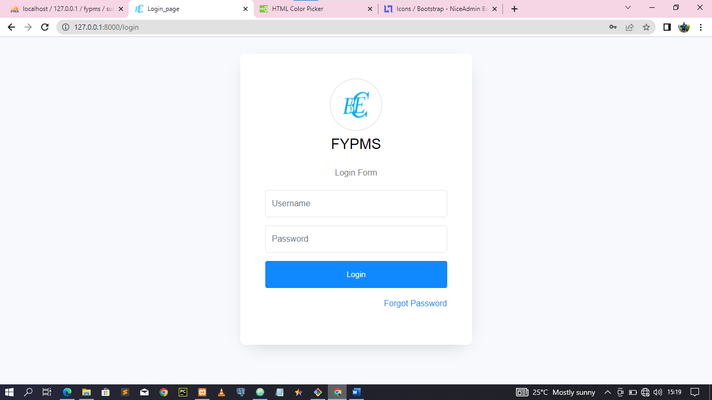

1. **USING SUPERVISOR MODULE**

This is a module for supervisor in which all FYPMS features related to supervisors’ operations can be accessed. These include, Assigned Groups, Assess Groups and Announcements, Edit Profile and Change password. Features in this module are user friendly and easy to understand when used along with this manual. Figure 2 shows all features for supervisor FYPMS operations.

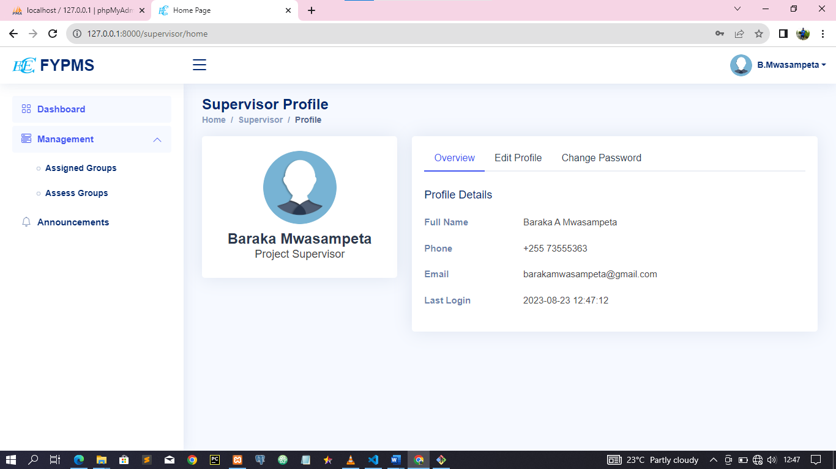

Figure Supervisor Features

* 1. **Management Feature**

This feature comprises of “Assigned Groups” and “Assess Groups”.Through this feature you can access your profile to view your details and status. If you wish to update your details such as profile picture or password, you can do it in your right-hand tabs by selecting the desired tab. If you update any information in your system, remember to save changes. Figure 3 shows features comprised in the Project Feature.



Figure Management features

### **Assess Groups**

Here you assess each group by providing marks to each student in a group separately. Remember to save the form of assessment and ensure you get the assessment was successfully message after submit the form.

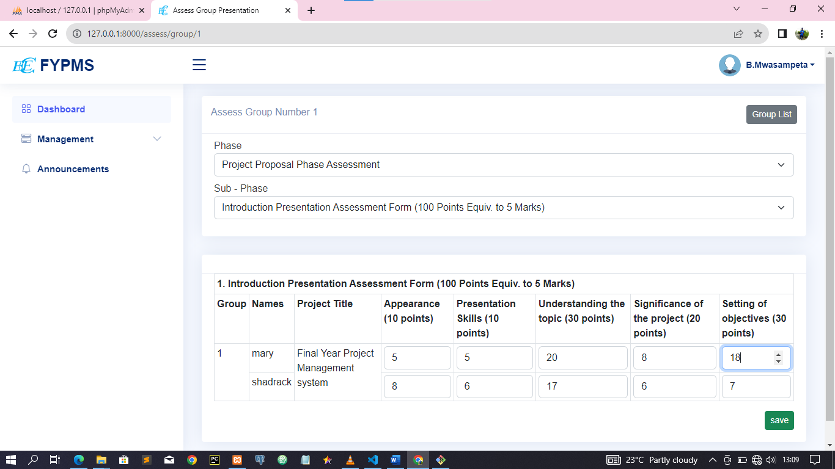

Figure assess group

1. **Announcement**

This feature allows you to view Announcement published to the system by project coordinator it shows the announcement with the time announcement was published.

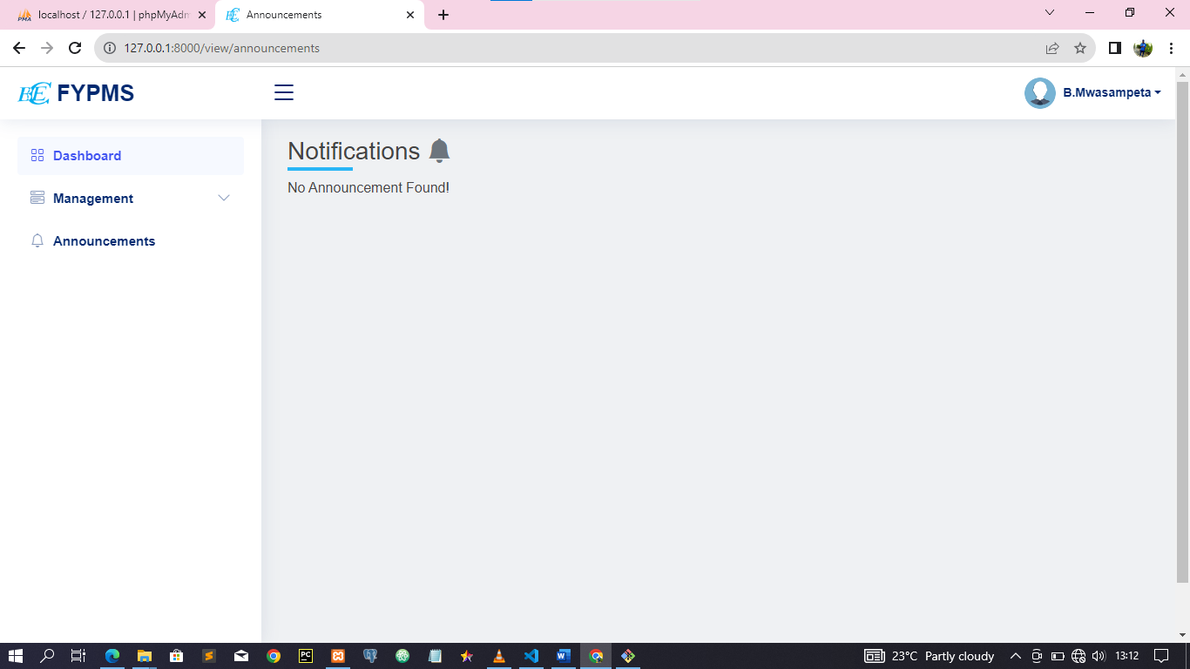

Figure Announcement feature

1. **Log Out**

The last feature on the student module panel is log-out. Once you have finished working in FYPMS, you will use the “Log Out” feature to sign out from the system. This will end your current FYPMS session, and you will be required to start all over again in section 5, if you wish to continue using the FYPMS.